SIMATS ENGINEERING
ASSESSMENT TOOL 1

COURSE CODE: CSA14 COURSE NAME: Compiler Design

COURSE OUTCOME COVERED

CO4: Examine intermediate code generation techniques to enhance code optimization (BL4)

Assessment Tool Weightage: 40%

QUESTIONS: 4 Total Marks:40

Annexure A

CLASS TEST

Code of Conduct:

I ____M.Madhu Rushwika(192371066)________________ (Name / Reg No) certify that this submission is my original work and that I have adhered to the guidelines specified for this assessment.
I understand that any violation of academic integrity rules will result in disciplinary action.

Signature of the student: M.Madhu Rushwika

Q. No | Understanding of Concepts (25) | Explanation (25) | Application (20) | Organization(15) | Accuracy(10) | Total Score  (out of 100)
1 | / 4 | / 4 | / 4 | / 4 | / 4
2 | / 4 | / 4 | / 4 | / 4 | / 4
3 | / 4 | / 4 | / 4 | / 4 | / 4
4 | / 4 | / 4 | / 4 | / 4 | / 4
5 | / 4 | / 4 | / 4 | / 4 | / 4
OVERALL RUBRICS VALUE
 | / 4 | / 4 | / 4 | / 4 | / 4
 | / 25 | / 30 | / 20 | / 15 | / 10 | / 100

Annexure A

CLASS TEST
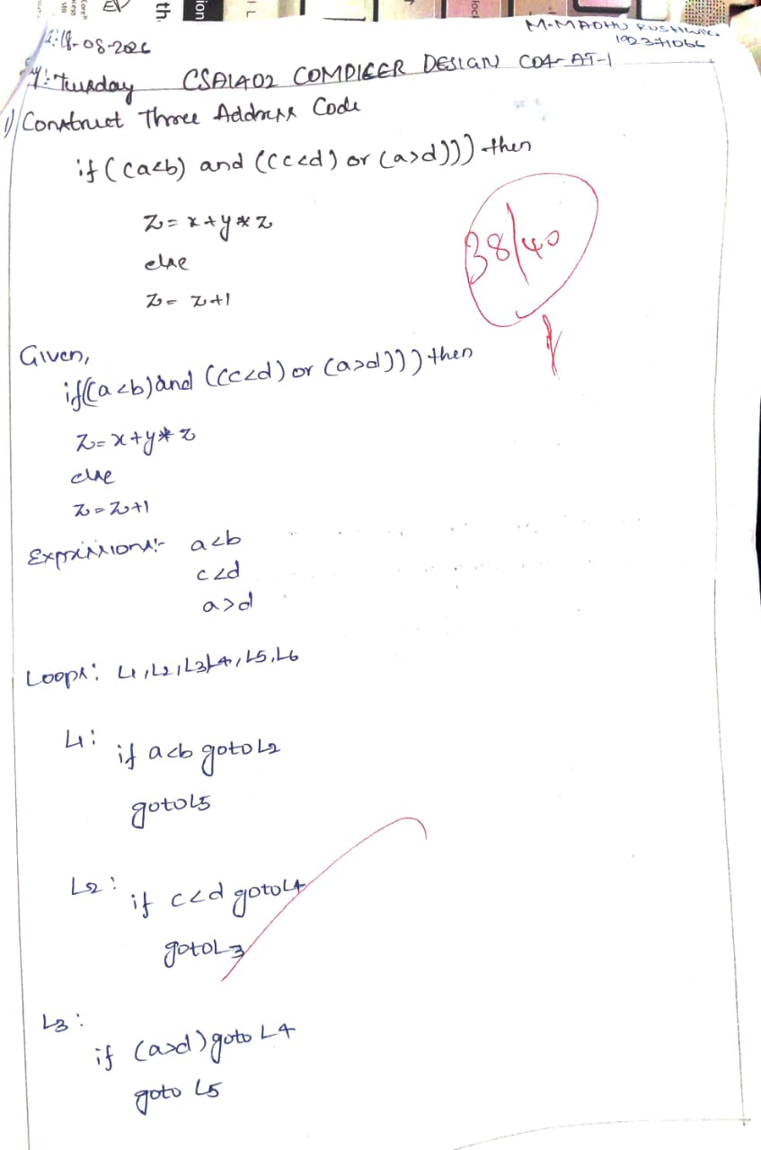

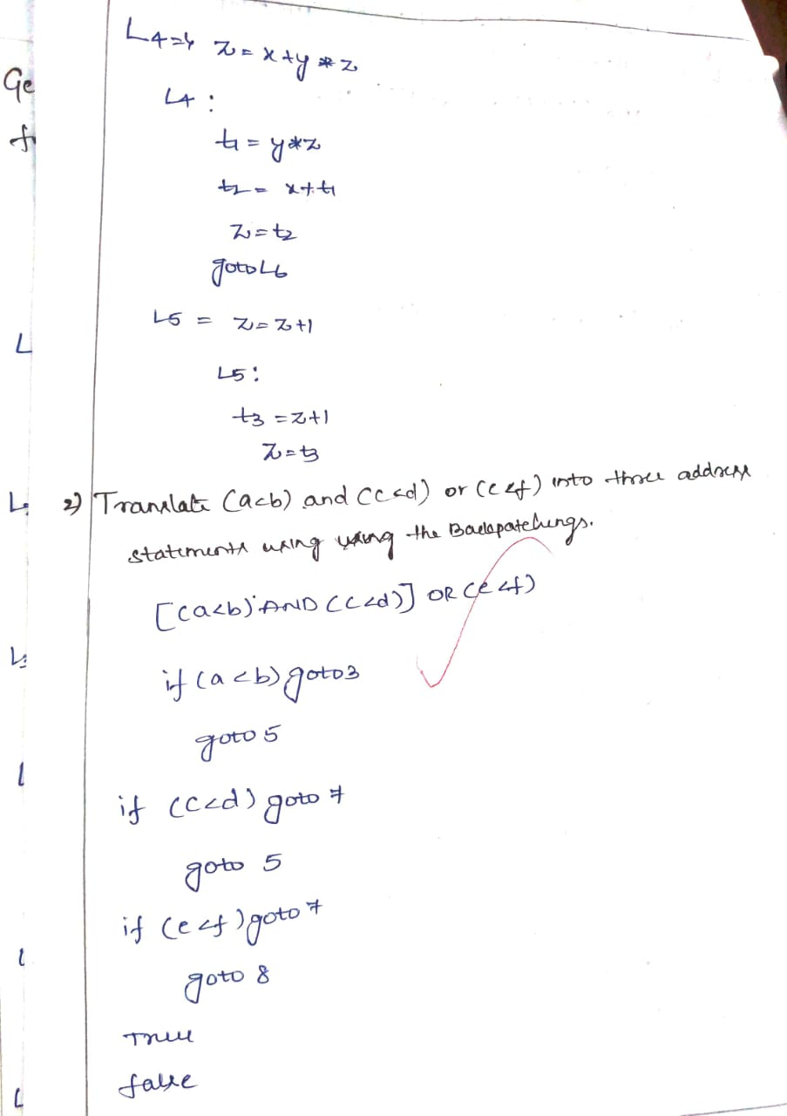
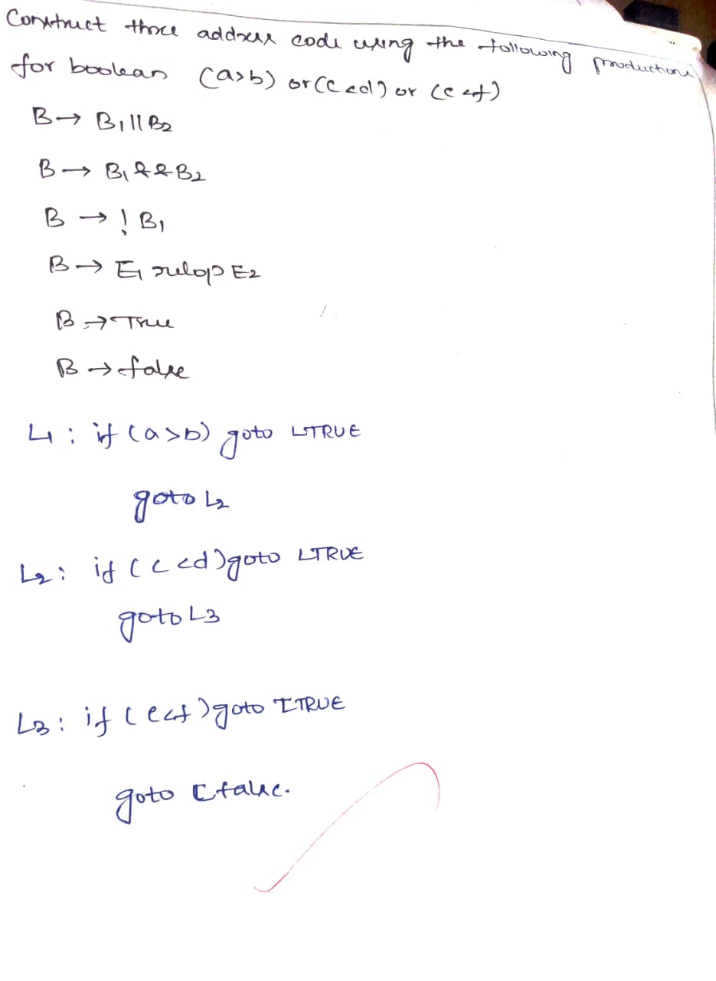

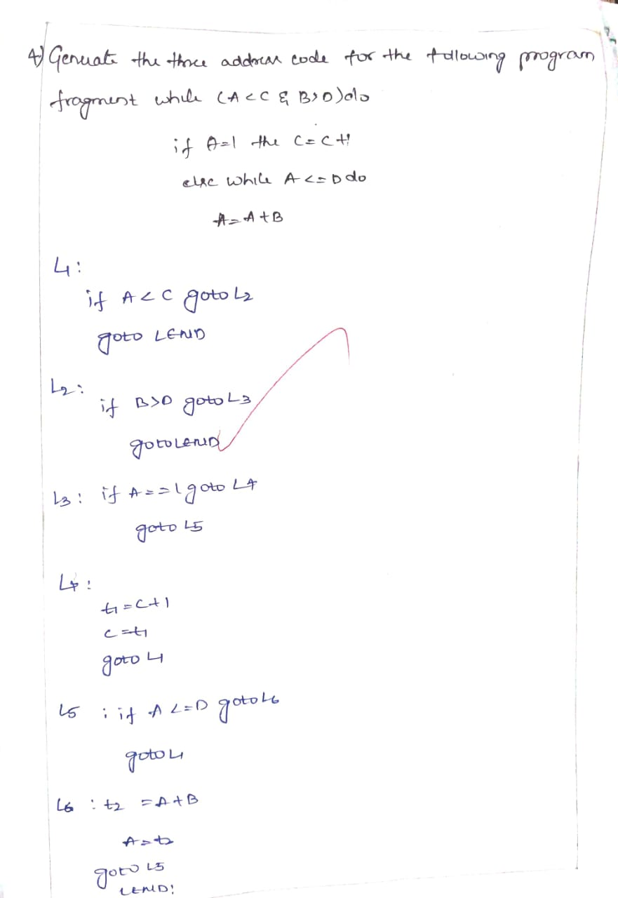

RUBRICS FOR CALCULATION

Criteria | Weightage | Level 4 – Exemplary | Level 3 – Proficient | Level 2 – Developing | Level 1 – Beginning
Understanding of Concepts | 25% | Demonstrates thorough, accurate understanding of concepts | Good understanding with minor gaps | Basic understanding with some misconceptions | Poor understanding; major misconceptions
Explanation | 25% | Detailed, well-explained answers with relevant examples | Clear explanation with adequate details | Limited explanation; lacks depth | Poor or unclear explanation
Application | 20% | Effectively applies concepts with strong analytical ability | Applies concepts with minor errors | Limited application with weak analysis | No application or incorrect analysis
Organization | 15% | Well-structured answers with logical flow and coherence | Organized with minor issues in flow | Basic structure, lacks clarity | Poor organization, incoherent answers
Accuracy | 15% | Completely accurate and covers all required points | Mostly accurate with minor omissions | Partially correct with missing points | Incorrect answers with major gaps

